[Barrett and Bolt (2007)][#barrett07]

(1) Staging the Research

(2) The literature and practice review

(3) Materials Methods and Conceptual Frameworks

(4) The Exegesis: Discussion of the Studio Research Process

(5) Discussion of the Outcomes and Significance

(6) Writing the Conclusion

(7) The Abstract

(8) Writing the Creative Arts Research Paper: A Summary

(9) Citation and Referencing

(10) Appendix

--

(1) Staging the Research

'What did the studio process reveal that could not have been revealed by any other mode of enquiry?'

locate the work in contexts of practice and contexts of theory

stablise the research discipline.

design studio enquiry as a research project
- problem with the pre-determination of outcome
- praxis - move between what is known and what will be revealed

introduction born of the proposal

The introduction asks:

What is the subject or topic to be investigated?
What are the specific areas of interest and what ideas and positions have other studio practitioners taken in relation to these?
What is the research question or hypothesis?
What is the research objective or aim -- what will be acheived at the end of the process?
What is the main thesis or argument?
How will this be developed in the research paper?

Stages of the Research

Stage 1: Establish the field: asserting the centrality and need for this enquiry - how is it significant?

State current practice and knowledge
Summarise what is know and formulate the problem

Stage 2: Summarise Previous Practice and Theory
Always from the perspective of THIS research, clearly stating the relationship between THIS research and the whole field

Stage 3: Justification: Find the GAP in the existing knowledge and raise a KEY question

Outline the studio process and chapters of the exegesis or sections for the paper

Stage 4: Introduce Present Research
State Purpose
State Hypothesis / thesis
Outline Approach: what methods of studio enquiry and analytical / conceptual frameworks
Outline Chapters (rationale for chapters)
Outline the research project itself

----
Move from the general to the specific
Make an argument to convince the reader of the importance of the research.

(2) The literature and practice review

broaden the topic
and narrow the topic indicating the scope of the research
adjust critical focus

visual material
scholarly texts
referencing and citation

apprehension of and response to movement - tricky to capture

provide context and pedigree for the practice.

locate the research in a historical and contemporary context (DIACHRONIC)

methodological comparison and discussion

indicate gaps

demonstrate how practice informs theory

--

Reading should be:

Inspirational
raise immediate questions
inspire or clarify practice
advance the thesis

--

Apply the following questions to the literature review:

How does it support my position?

How can my postition be a critique or interrogation or clarification of the surveyed material?

How does it provide background or context?

Is the theoretical paradigm or fundamental concepts part of the material part of the analytical framework?

What gap does the project fill?

Practice is primary and not simply an illustration of theory.

the chinese room ...

(3) Materials Methods and Conceptual Frameworks

bricolage

historical connections

media archeology

materials are encoded with historical knowledge and conventions and are inextricably linked to conceptual and theoretical frameworks

Materials, Methods and Assumptions

digital technologies provide new and different ways of revealing and modelling and simulating (adapted from Barrett and Bolt)

JUSTIFICATIONS
New forms of expression or way of revealing
Technical Solutions
Innovation
Fun

Genres
"The artist as researcher may want to celebrate critique, extend, revise or even incriminate the work of earlier practitioners." [192][#barrett07]

Observation
What happened? What changed; What was revealed? What is significant (what was revealed that could not have been revealed through any other method of enquiry?)

Ethical Considertations
Nature of Representation;
Appropriation of material and copyright issues;

Conceptual / Theoretical Framework

This is difficult for creative arts researchers.
[reception theory, semiotics]

(4) The Exegesis: Discussion of the Studio Research Process

AIM: replicate the studio enquiry in the context of theoretical ideas and practices.

Outcome identification
Key moment identification
breakthroughs
outline details of methods/materials/processes that led to breakthroughs or new understandings...

Compare with the work of others

When to write the exegesis: there should be a sustained dialogue between studio work and writing.

MEMO: Visual Diary / Research Notes

(5) Discussion of the Outcomes and Significance

complete studio work
journals / archives / and scholarly research

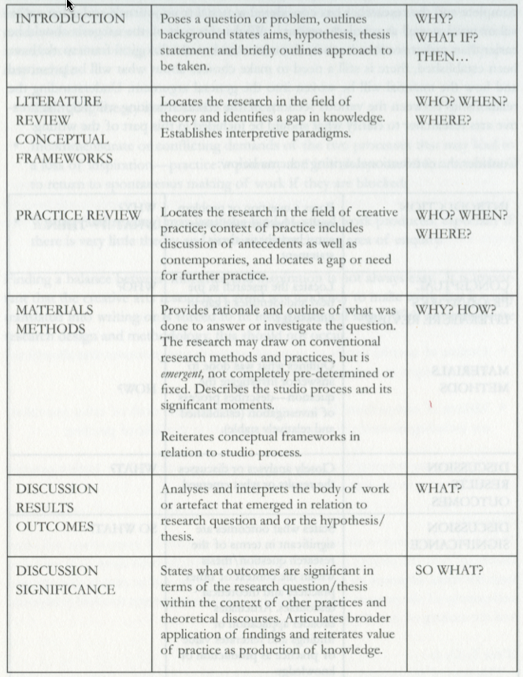

The above is a good start for the creative arts researcher - but some more thematic arrangements of sections with titles

CONCEPT: re-versioning / retelling retell the process within a wider context
the discussion should always reflect back to the HYPOTHESIS or thesis statement

Visuals - labelled and numbered. Referenced...

DISCUSSING THE SIGNIFICANCE OF THE WORK

significance relates to connections
significance relates to building theory and practice
whether the work challenges existing ideas
how has the work advanced or solve particular problems (expression)
how can the research be extended and applied (beyond the creative arts)

(6) Writing the Conclusion

Nothing NEW;
Synthesis, set down broad generalisations that validate the thesis statement or hypothesis;
relate to AIMS and OBJECTIVES;
Point out implications;
Reiterate value and significance of the project;
Make recommendations for future work;
Critique limitations of the research process;

(7) Practice as Research: The Abstract

Aims
Methods / Content
New Understandings / Outcomes
Significance and Relevance

Answer the following questions:
Why do the research?
How was the research conducted
What were the main outcomes and Results
What were the principle conclusions
What is the significance of the research

State what the practical enquiry will reveal that other modes may miss

(8) Writing the Creative Arts Research Paper: A Summary

* What did the studio enquiry reveal that may not have been revealed through other modes of enquiry?
* What methods and approaches were developed through the studio production that allowed discoveries to be made?
* How does the completed work perform, model or demonstrate the new knowledge/understandings gained through the studio process?
* How might these understandings be applied both within the field and creative arts discipline as well as beyond it?
* How does practice inform theory?

(9) Citation and Referencing

(10) Appendix

